BUSINESS INSIGHT REPORT
Northwind Traders — Interactive Sales Dashboard
A Power BI Data Analysis Project

PREPARED BY: PAVITHRA E
COURSE : BCOM FINTECH WITH AI
REGESTER NO : 5272510214

1. Introduction

Northwind Traders Dataset
The North wind Traders dataset is a well-known relational sample dataset representing a specialty food import/export company. The dataset used in this project (DATASET_3.pbix) contains seven related tables — categories, products, customers, employees, orders, order_details, and shippers — capturing 809 orders placed between July 2013 and May 2015 by 91 customers across 21 countries, covering 77 products organised into 8 product categories and handled by a team of 8 sales employees.

Purpose of the Dashboard
The Power BI dashboard built on this dataset gives business stakeholders a single interactive view of overall sales performance. It surfaces headline KPIs (orders, quantity, freight and customer counts), shows how sales are distributed across product categories, tracks the monthly order trend, and compares performance across the sales team — all of which can be filtered instantly by Year, Country and Category using the on-page slicers.

Purpose of the Business Insight Report
This report interprets the dashboard's KPIs and visuals, translating raw observations into business insights and actionable recommendations. Each analytical section below distinguishes between an observation (what the data literally shows) and an insight (what that observation means for the business), before closing with a consolidated set of recommendations for management.

2. Dashboard Overview
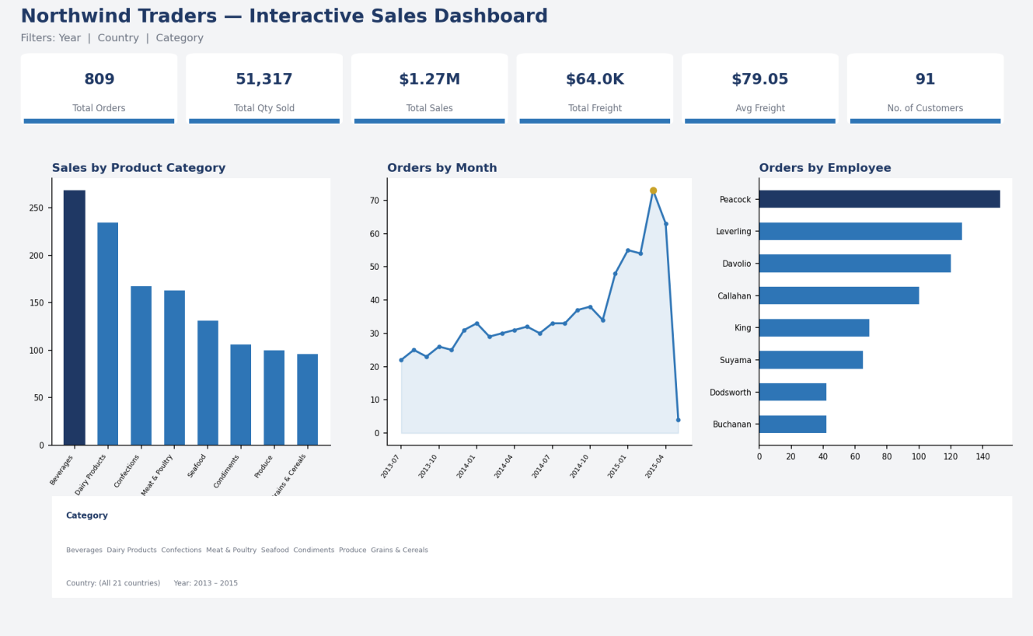
The dashboard's purpose is to let a sales manager assess overall business health at a glance and then drill into whichever dimension — time, category, employee or geography — needs attention.

Key Components
- Five KPI cards: Total Orders, Total Quantity Sold, Total Freight, Average Freight, and Number of Customers.
- Sales by Product Category — a column chart ranking the 8 product categories by total sales value.
- Orders by Month — a line chart tracking order volume across the full 2013–2015 date range.
- Orders by Employee — a bar chart ranking the 8 sales employees by number of orders handled.
- A Category Tooltip page that surfaces Total Sales, Total Orders and Total Quantity Sold on hover.

Interactive Filters Available
- Year — filters all visuals to a single order year (2013, 2014 or 2015).
- Country (Region) — filters all visuals to a selected customer country.
- Category — filters all visuals to a single product category.

3. KPI Analysis
Total Orders — with 809 distinct orders recorded, the business maintains a steady, consistent order flow across nearly two full years of trading, averaging roughly 35 orders per month.
Total Quantity Sold — 51,317 units were sold in total, indicating healthy per-order volume (an average of about 63 units per order across all product lines).
Total Freight — cumulative freight cost across all orders was $63,955.02, meaning shipping is a material and recurring cost line that scales directly with order volume.
Average Freight — at $79.05 per order, freight represents a non-trivial cost per transaction; monitoring this figure by carrier and region can reveal cost-saving opportunities.
No. of Customers — the dashboard reflects 91 unique customers, giving a picture of the breadth of the company's customer base relative to its 809 orders (roughly 9 orders per customer on average).
KPI | Value | Interpretation
Total Orders | 809 | Consistent order flow (~35 orders/month) over the two-year window.
Total Quantity Sold | 51,317 units | Healthy per-order volume; ~63 units sold per order on average.
Total Freight | $63,955.02 | Shipping is a material, recurring cost tied directly to order volume.
Average Freight | $79.05 | Meaningful per-order cost; worth tracking by carrier/region.
No. of Customers | 91 | Broad customer base; ~9 orders per customer on average.

4. Product Category Performance Analysis
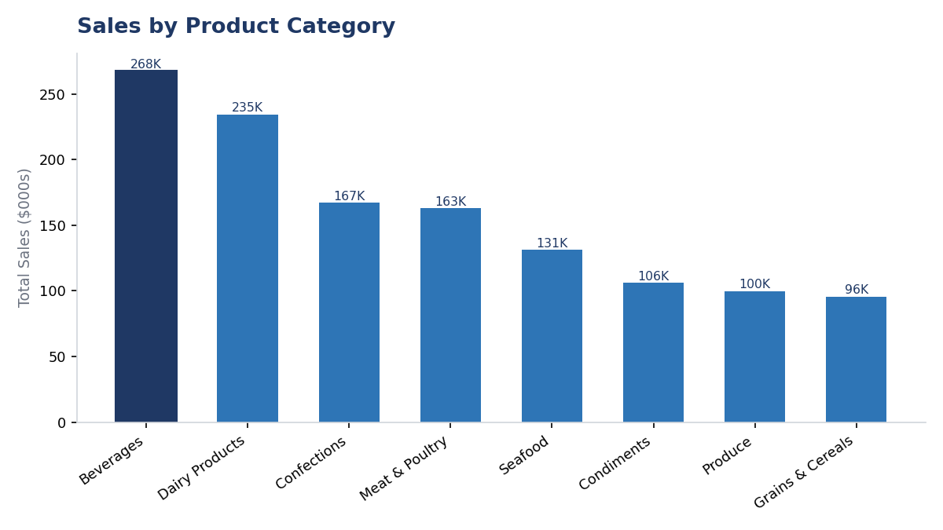

- Highest-selling category: Beverages, at $267,868.18 in total sales — the single largest revenue contributor.
- Lowest-selling category: Grains & Cereals, at $95,744.59 — the smallest of the eight categories.
- Relative difference: Beverages outsells Grains & Cereals by $172,123.59, i.e. Grains & Cereals generates about 64% less revenue than the top category.
- Important observation: the top two categories, Beverages ($267,868.18) and Dairy Products ($234,507.29), together account for roughly 40% of total company sales, while the bottom three categories (Condiments, Produce, Grains & Cereals) combined contribute less than 24%.

Key Insight
Revenue is concentrated in a small number of categories. Beverages and Dairy Products alone drive close to 40% of total sales, meaning the business's performance is disproportionately exposed to demand shifts in just two product lines, while several categories remain comparatively under-leveraged.

5. Monthly Order Trend Analysis
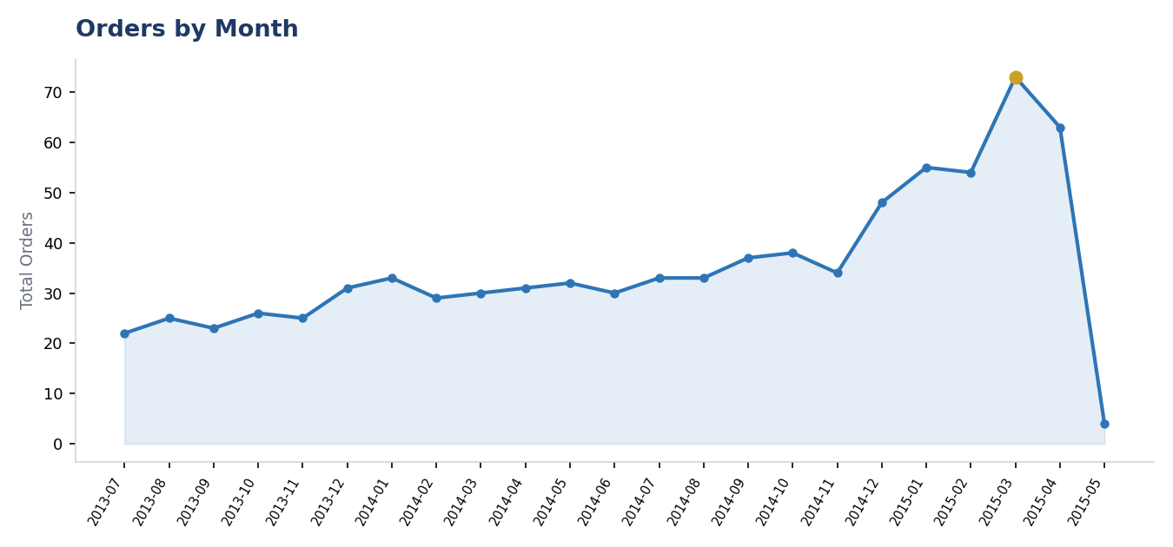

- Highest-order month: March 2015, with 73 orders — the single busiest month in the dataset.
- Lowest-order month: July 2013, with 22 orders — the first month of trading, before the customer base had built up (May 2015 shows only 4 orders, but this reflects a partial month, as the dataset ends on 4 May 2015, rather than a genuine demand drop).
- Overall pattern: order volume rises steadily and almost continuously from mid-2013 through early 2015, climbing from the low-20s to the low-70s per month.
- Major fluctuation: growth accelerates sharply from December 2014 (48 orders) through March 2015 (73 orders), a jump of over 50% in three months, the steepest sustained rise in the whole series
.

Key Insight
The business shows genuine, sustained growth rather than seasonal noise — order volume more than trebled from the first recorded month to the peak month. The late-2014-to-early-2015 acceleration in particular suggests either a successful sales push, new customer acquisition, or seasonal buying patterns that management should plan capacity around.

6. Regional / Filter-Based Analysis
The dashboard does not use a separate regional chart; instead, every visual responds to the Country slicer. Selecting Germany, the USA and Brazil in turn — the three countries generating the most orders — shows clear differences in KPIs, category mix and top-performing employee.
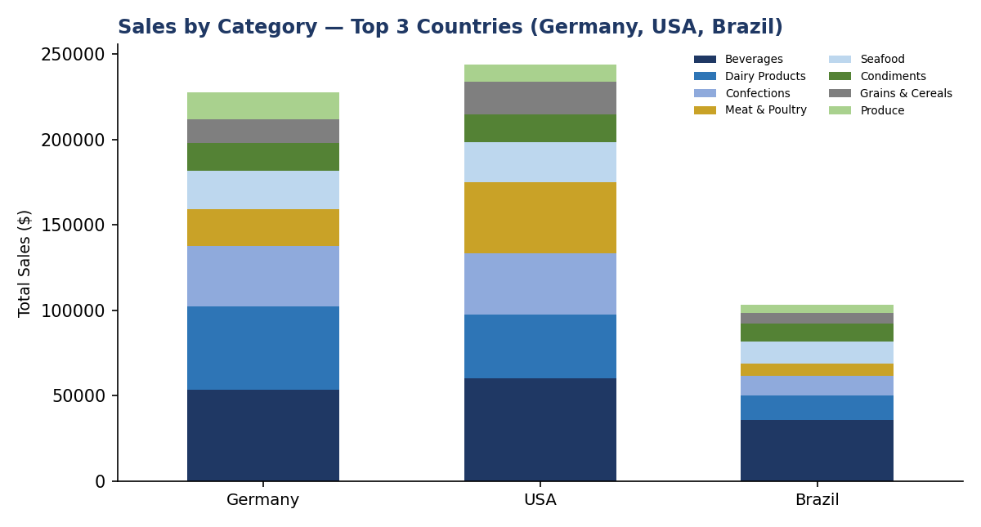

Region | Major Observation | Business Insight
Germany | 120 orders, $227,796.66 in sales from 11 customers; Beverages is the top category ($53,699); Margaret Peacock is the top-performing employee (25 orders). | Germany is the most order-dense market and already well served by the top sales rep — a strong candidate for account-growth and loyalty programmes.
USA | 119 orders, the highest sales value of any country ($243,618.89) from 13 customers; Beverages leads ($60,090.98); Janet Leverling is the top employee (21 orders). | The USA is the single largest revenue market; performance here depends more on Janet Leverling than on Margaret Peacock, showing employee strength varies by territory.
Brazil | 81 orders, $103,060.70 in sales from 9 customers; Beverages again leads ($35,785.84); Margaret Peacock is the top employee (20 orders). | Brazil trails Germany and the USA by a wide margin despite a comparable customer count, suggesting room to grow order frequency per customer.

What Changes When the Region Filter Is Applied
- KPI changes: Total Orders, Total Sales, Total Freight and Number of Customers all scale down sharply for any single country compared with the all-country totals, confirming no one country dominates the overall figures.
- Category changes: Beverages remains the top category in all three leading countries, but the ranking of the remaining categories shifts — for example, Meat & Poultry moves up in the USA's mix relative to Germany's.
- Monthly order changes: filtering by country reduces the smoothness of the monthly trend line, since each country contributes far fewer orders per month, making individual months more volatile.
- Employee performance changes: the top-performing employee changes by country — Margaret Peacock leads in Germany and Brazil, but Janet Leverling leads in the USA — showing that sales performance is not uniformly driven by one employee globally.

7. Employee Performance Analysis
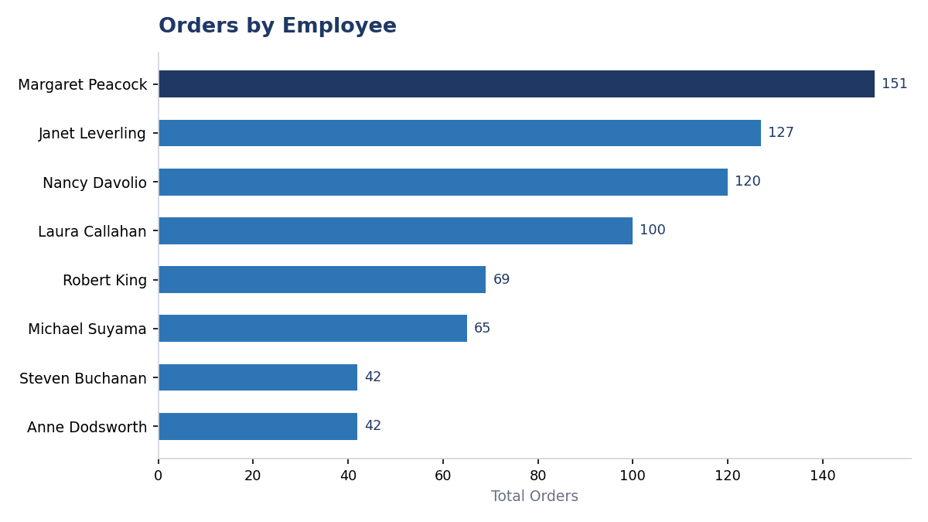

- Highest-performing employee: Margaret Peacock, with 151 orders handled — the clear top performer.
- Lowest-performing employees: Anne Dodsworth and Steven Buchanan are tied for the lowest order count, at 42 orders each.
- Difference between employees: Margaret Peacock handled 109 more orders than the lowest-performing employees — roughly 3.6 times as many.
- Changes after applying filters: when the dashboard is filtered to Germany or Brazil, Margaret Peacock remains the top performer; filtered to the USA, however, Janet Leverling overtakes her, showing that employee ranking is territory-dependent rather than fixed.

Key Insight
Order volume is unevenly distributed across the sales team. The top employee manages more than three-and-a-half times the orders of the lowest performers, which may reflect differences in territory size, tenure, or account assignment rather than pure effort — a pattern worth investigating before drawing conclusions about individual performance.

8. Business Insights

Insight 1 — Revenue Is Concentrated in Two Categories
Observation: Beverages and Dairy Products together generate close to 40% of total sales, while the bottom three categories combine for less than a quarter of revenue.
Insight: The business carries meaningful concentration risk — a demand shock in Beverages or Dairy Products would disproportionately affect total revenue, and under-performing categories represent untapped growth potential.

Insight 2 — Growth Is Accelerating, Not Flat
Observation: Monthly orders climbed from 22 in July 2013 to 73 in March 2015, with the steepest rise occurring between December 2014 and March 2015.
Insight: The business is in a genuine growth phase rather than a mature, flat-demand state, which has direct implications for inventory, staffing and logistics planning going into future peak periods.

Insight 3 — Sales Performance Is Uneven Across the Team and Across Regions
Observation: Margaret Peacock handles 3.6 times more orders than the lowest-performing employees, and the top-performing employee changes depending on which country is selected.
Insight: Success is not being replicated evenly across the sales organisation. Understanding why certain employees or regions under-perform — territory size, account quality, or support — could unlock meaningful additional revenue.

Insight 4 — Core Markets Carry the Business
Observation: Germany, the USA and Brazil together account for roughly 40% of all orders, while the remaining 18 countries share the rest, several with only a handful of customers each.
Insight: The customer base has a long tail of low-volume markets alongside a small core of high-volume ones, meaning growth strategy should treat 'expand the core' and 'develop the long tail' as two distinct initiatives.

9. Business Recommendations
- Product category planning: Invest in targeted marketing and promotions for Grains & Cereals, Produce and Condiments — the three lowest-performing categories — to reduce reliance on Beverages and Dairy Products.
- Inventory planning: Increase stock levels of Beverages and Dairy Products ahead of the observed Q4–Q1 demand surge (December–March) to avoid stockouts during the business's busiest period.
- Regional strategy: Prioritise account-growth initiatives in the USA and Germany (the two largest markets) while running acquisition campaigns in mid-tier markets such as France and the UK to narrow the gap with the top three countries.
- Employee performance: Review territory and account assignments for lower-volume employees such as Anne Dodsworth and Steven Buchanan, and consider pairing them with the practices of top performers like Margaret Peacock and Janet Leverling.
- Monthly order / capacity planning: Align staffing, warehousing and logistics capacity with the December–April peak season, given order volume nearly triples relative to the July 2013 baseline.
- Freight management: Investigate the drivers of the $79.05 average freight cost — carrier choice, shipment size, and destination — to identify potential savings, particularly for the highest-volume countries.
- Customer targeting: Launch cross-sell and upsell campaigns aimed at existing customers in Germany, the USA and Brazil, and run acquisition campaigns in countries with fewer than three active customers to broaden the base.

10. Conclusion
Overall dashboard findings: Northwind Traders processed 809 orders worth roughly $1.27 million in sales between July 2013 and May 2015, serving 91 customers across 21 countries. The dashboard shows steady, accelerating order growth, revenue concentrated in Beverages and Dairy Products, and an uneven distribution of order volume across both the sales team and the customer geography.
Most important business insight: the combination of category concentration and the recent acceleration in order growth is the most significant finding — the business is growing quickly but is depending heavily on a narrow set of categories and markets to sustain that growth.
Key recommendation: management should use the upcoming peak season (informed by the clear December–March order surge) to simultaneously protect the core (Beverages, Dairy Products, Germany, USA, Brazil) and actively grow the long tail (under-performing categories, employees and countries) before the next growth cycle begins.
How Power BI helped: the interactive dashboard made it possible to move directly from headline KPIs to category-, time- and region-level detail using a small set of slicers, turning a flat set of seven data tables into a tool that supports fast, evidence-based business decisions rather than static reporting.

